B. Administrative Action:

Additional Information/or Administratve Follow Up:

1. Further Medical Follow-up:

Preventive Measures: (For Provider’s Internal use)

Body Part Injured:

☐ Head or Face ☐ Neck or Chest ☐ Mouth/Teeth

☐ Abdomen ☐ Hands/Arms ☐ Back/Buttocks

☐ Feet/Legs ☐ Genitals ☐ Other______________________

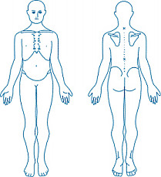

R

Signature: Date:

**Date**

Others involved:

Relationship to Individual:

Immediate Action to Ensure Health and Safety of Individuals:

Injury- Describe Type & Location:

Date of Incident: Time of Incident: AM/PM

Description of Incident(Who, What, Where, When):

Location of Incident (home in bathroom, at the mall, lunchroom a work):

City/County:

DOB:

**DODD-Possible or determined MUI Report Form**

**Preston Homes**

**2700 Hill Ave**

**Toledo,OH 43607**

County Board

SSA

CPSA

LE

Staff or Family living at the individual’s home & responsible for the individual’s care

Licensed or Certified Provider

Guardian/Advocate

**Name /Title**

**Type of Notification**

Witnesses to Incident:

Name of PPI(s):

Address:

Individual’s Name: